**Part 1 : Transfer learning**

* **We have seen that the training time less when compared with from scratch**
* **We have used Alexnet_weights as pre-trained weights**
* **The cifar100 is big data set with very 100 classes. So compared with cifar10, cifar100 has less accuracy**
* **Attaching the tensorboard output below:**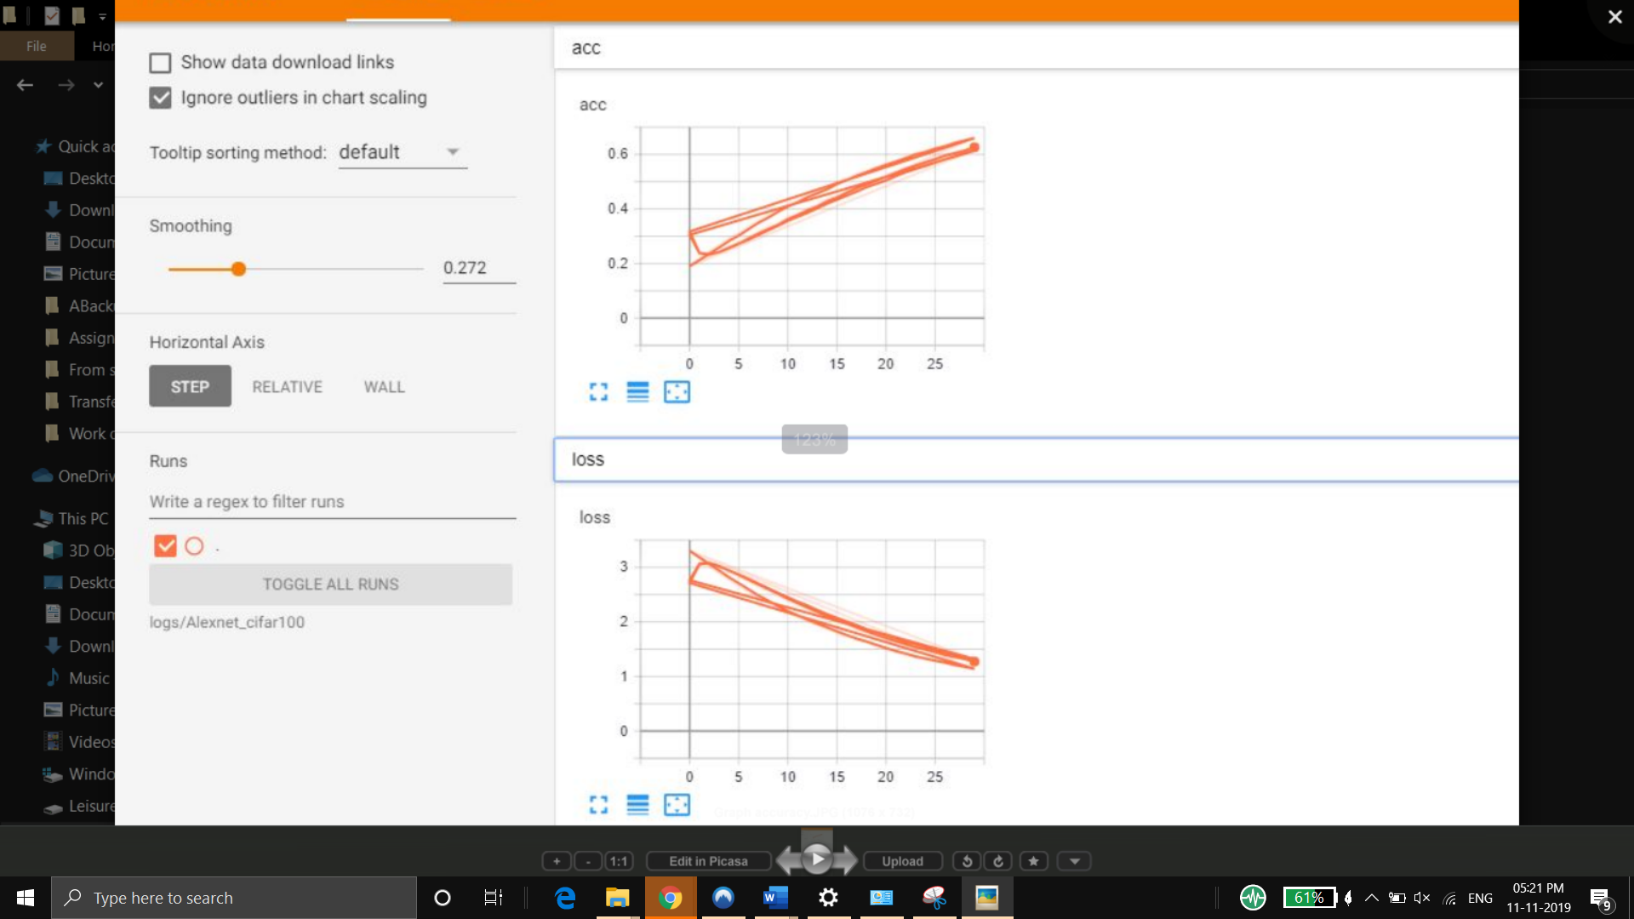

**Part 2 Learning from Scratch:**

* **Learning from scratch doesn’t need any weights**
* **The weights are trained from very beginning**
* **It takes more time to when compared with transfer learning**
* **Attaching the tensorboard output of learning from scratch model:** 